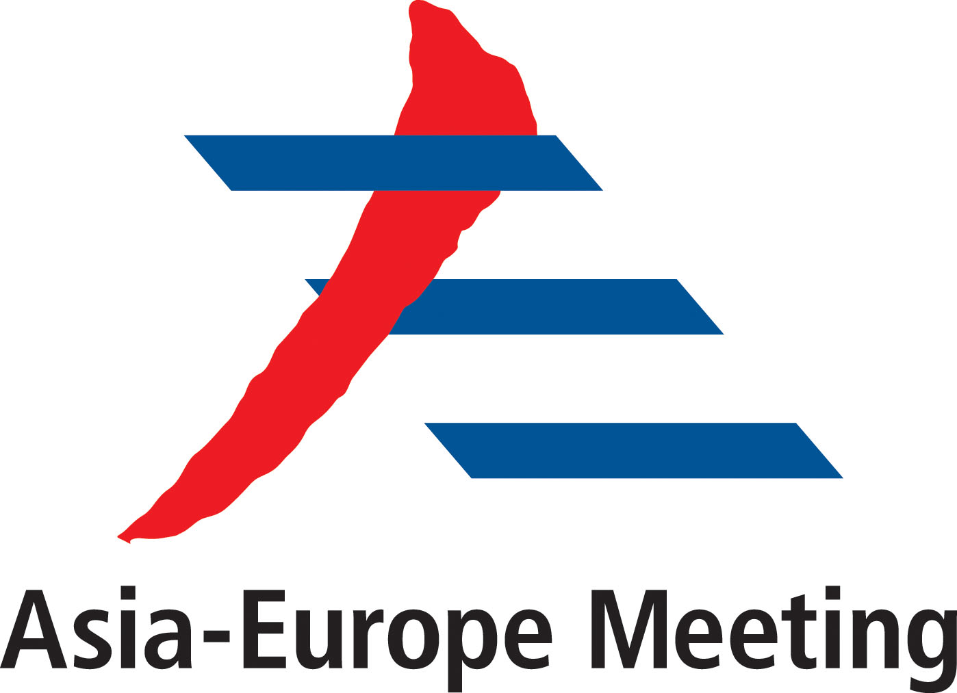
ASEM Think-tank Symposium
Connectivity: Opportunity to Boost ASEM Cooperation
Co-sponsored by China, Mongolia, Singapore and Poland
22-23 July, 2014, Shanghai, China

AGENDA

Monday, July 21st, 2014:
All Day: Arrival of Delegates

Tuseday, July 22nd, 2014:
08:30-09:00 Registration
09:00-09:15 Opening Session
- Welcoming Remarks by CHEN Dongxiao, President of Shanghai Institute for International Studies
- Opening Statement by Amb. Zhang Xiaokang, Chinese ASEM SOM

09:15-12:00 Session one: Connectivity and ASEM
Moderator: Stefan Hudjitodorov, Advisor to President, Bulgarian Academy of Sciences

09:15-10:15 Presentation (10 minutes for each)
- Status of connectivity within ASEM space and ASEM efforts to enhance connectivity within members, by Norodom Sirivudh
- Role connectivity cooperation could play to revitalize the ASEM pragmatic cooperation, by Michael Frendo, member of the Executive Board of TPPI and former Speaker of Parliament of Malta
Open Discussion (40 minutes)

10:15-10:40 Photo Session & Coffee Break
10:40-12:00 Presentation
- Feasibility of mainstreaming cooperation on connectivity in ASEM
by Jørgen Ørstrøm Møller，Visiting Senior Research Fellow, Institute of Southeast Asian Studies (ISEAS), Singapore
by Valentin Nagy-Simek, Minitry of Foreign Affairs, Hungary
- The multi-dimensional impacts of enhanced ASEM connectivity
by Zhai Kun, Director of the Institute of World Political Studies，China Institutes of Contemporary International Relations (CICIR)
by Tina S. Clemente, Assistant Professor, Asian Center, University of the Philippines-Diliman
Open Discussion (35 minutes)

12:00-13:30 Lunch
13:30-17:00 Session two: Opportunity and Challenges
Moderator: Jusuf Wanandi，Vice Chair, Board of Trustees, Center for Strategic and International Studies, Indonesia

13:30-15:10 Presentation
- ASEM connectivity seen from East Europe, Cyril Svoboda, Former Vice-Premier and Foreign Minister of Czech
- Needs and expectations from Asian developing members, by Fazal ur Rahman, Executive Director, Pakistan Council on China
- Opportunities and challenges for ASEM landlocked countries, by ENKHBAIGALI Byambasuren, Director of the National Development Institute of Mongolia, Mongolia
- Needs and expectations from European developed members, Francoise Nicolas, Senior Research Fellow & Director, Centre for Asian Studies, IFRI, France
- Needs and expectations from Asian developed members, EOM Gu Ho, Director, Asia-Pacific Research Center, Hanyang University, Republic of Korea
- Opportunities for ASEM connectivity brought by China’s strategy of “New Silk Road Economic Belt”, by Cui Hongjian, Director of the Department for European Studies, China Institute of International Studies (CIIS)
Open Discussion (40 minutes)

15:10-15:30 Coffee Break
15:30-17:10 Presentation
- Challenges to connect a most diversified ASEM space, Tan Khee Giap, Associate Professor & Co-Director, Asia Competitiveness Institute, Lee Kuan Yew School of Public Policy, National University of Singapore
- ASEM connectivity seen from a geo-strategic view, Jagannath Panda, Research Fellow, Institute for Defence Studies and Analyses (IDSA), India
- An industrial and commercial look at ASEM connectivity, by Marco Costa, Studies Centre CESEM, Italy
- Remedy to conflicts between the forum nature of ASEM and the pragmatic nature of ASEM connectivity, by Fraser Cameron, Director, EU-Asia Center, EU
- Implication of major power relationship in ASEM connectivity, By Pang Zhongying, Renmin University
- By Sameer Kumar, Asia Europe Institute, University of Malaysia
Open Discussion (40 minutes)
17:10 Dinner

Wednesday, July 23rd, 2014:
09:00-10:30 Session three: The Way Forward to an interconnected ASEM
Moderator: Norodom Sirivudh, Founder and Chairman, Board of Director, Cambodian Institute for Cooperation and Peace (CICP), Cambodia
- China’s proposal, by GAO Zhenting, MFA, China
- Areas for pragmatic cooperation, by Stefan Hadjitodorov, Advisor to the President, Bulgarian Academy of Sciences
- EU’s vision and proposal, by Veronica Musilova, ASEM Desk Officer
- ASEAN’s plan, by Jusuf Wanandi，Vice Chair, Board of Trustees, Center for Strategic and International Studies, Indonesia
- Role ASEM could play for concerted efforts of Asia and Europe, by Artur GRADZIUK，International Economic Relations and Global Issues, Program Coordinator, the Polish Institute of International Affairs
Open Discussion (40 minutes)

10:30-10:45 Coffee Break
10:45-11:50 Session four: Role of Think Tanks to enhance ASEM connectivity
Moderator: YANG Jiemian (7 minutes for each)
- Shada Islam, Director of Policy, Friends of Europe, EU
- Khin Maung Lynn, Joint Secretary, the Myanmar Institute of Strategic & International Studies (MISIS)
- Rudolf Furst, Director, Institute of International Relations, Czech Republic
- Alka Acharya, Institute of Chinese Studies, India
- Tran Viet Thai, Deputy Director-General, Institute for Foreign Policy and Strategic Studies, Diplomatic Academy of Vietnam
Open Discussion (30 minutes)

11:50-12:30 Closing Session: (10 minutes for each)
- Remarks by Veronica Musilova, ASEM Desk Officer
- Remarks by YANG Jiemian, Chairman of Academic Council of Shanghai Institutes for International Studies
- Adoption of the draft statement

12:30 Lunch
14:00-17:30 Cultural Trip (on voluntary basis)
注：1、建议会议采取圆桌形式，便于与会者交流。
2、马耳他、捷克人员系前政要，需报部批。
3、请上研院确定有分量的发言者，与其沟通做准备，争取发言者各有侧重。
4、请上研院确定一个参观项目，与会者自愿报名参加。
5、成果文件可于7月22日会前散发，请与会人员于22日晚提交书面修改意见。23日上午散发更新稿并通过，不安排案文磋商环节。

